  
 **National University of Computer and Emerging Sciences**

Human Computer Interaction

# “LSTM vs ARIMA”

**STUDENTS NAME:** Muhammad Azeem, Usman Ali, Taha Suhail

**ROLL NUMBERS:** i15-0148, i16-0164, i17-0045

**DEGREE PROGRAM:** BS(CS)

**SEMESTER:** Fall 2020

**SUBJECT NAME:** Deep Learning for Perception

**SUBMITTED TO:**  Sir Dr Atif Mughees

**SECTION:** A

**MARKS:**

__**__________________________________________________________**

**REMARKS:**

__**___________________________________________________________**

**TEACHERS SIGNATURE:**

__**___________________________________________________________**

Note: All excerpts provided will have links in the references as well as attachments in the email this was sent.

Contents

“Class Room Task – Train Booth Upgrade” 1

Introduction: 3

Why a hybrid model? 3

LSTM a bad choice? 3

Why a Hybrid ARIMA Model 4

Discussion 6

References 6

# Introduction:

The prediction code submitted as the Deep Learning Project aimed to be part of a bot that would accurately predict the Forex Trading for profit generation. The submission used data from 2001 to 2019 and deep learning models.

The considerations that were made needed to be very precise. This would allow the prediction of exchange rates for the coming day (as a general metric, can be hourly, daily, weekly or monthly). After much consideration and though, the trading bot would use the ARIMA model combined with a neural network.

# Why a hybrid model?

## LSTM a bad choice?

Many papers were considered in creating the prediction algorithm to understand, ascertain and get the most accurate results, since the maker of this bot as a package are a group of students in FAST Islamabad and will be using an ACCA graduate on their related field.

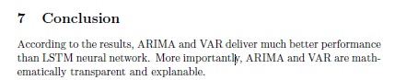The first paper that was considered was titled “Foreign Exchange Rates prediction with LSTM” authored by Huy Phung, Tashi Choden, Sahil Pasricha from University of Konstanz, Published: February 2019

Figure : Conclusion of the paper titled “Foreign Exchange Rates prediction with LSTM”

In this paper many different models were considered. The conclusion was to work with ARIMA or VAR models for a dataset which is time based. If the time split the dataset is based on (i.e. values are linear in the sense of days, hours or weeks) the model will not overfit. Otherwise the model with overfit with increasing coefficients

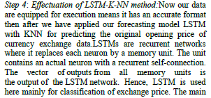The second paper that was considered was titled “Forecasting Foreign Currency Exchange Price using Long Short-Term Memory with K-Nearest Neighbor Method” authored by Rudra Kalyan Nayak, S.Y.H. Pavitra, Ramamani Tripathy, K. Prathyusha from International Journal of Engineering and Advanced Technology (IJEAT), ISSN: 2249 – 8958, Volume-9 Issue-2, December, 2019

This paper identifies that the LSTM is mainly used for smoothing and preparing the dataset whereas the KNN makes high predictability possible.

Figure : Result Discussion of the paper titled “Forecasting Foreign Currency Exchange Price using Long Short-Term Memory with K-Nearest Neighbor Method"

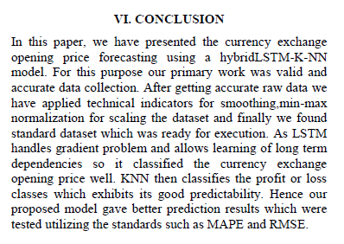This result from these two papers identifies the gap that the statistical model created when compared to the actual price was inaccurate when LSTM was solely used compared to the ARIMA model. Further literature review of other papers helped in finding out why to use ARIMA. Their findings are attached below.

Figure : Conclusion of the paper titled “Forecasting Foreign Currency Exchange Price using Long Short-Term Memory with K-Nearest Neighbor Method"

## Why a Hybrid ARIMA Model

The third paper considered was titled “An Enhanced Neural-based Bi-Component Hybrid Model for Foreign Exchange Rate Forecasting” authored by, M. Khashei, S. Torbat, Z. H. Rahimi from Turkish Journal of Forecasting vol. 01 no. 1 (2017) pp. 16-29 published in 2017.

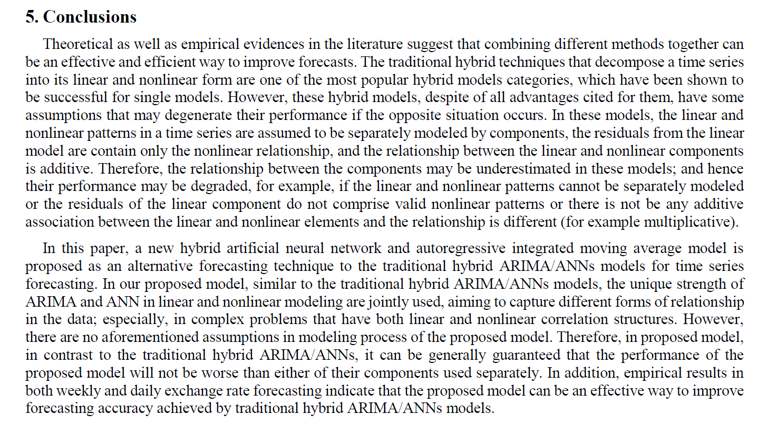This model discusses the similarities of the Auto-Regressive Integrated Moving Average (ARIMA) and forex rate forecasting with linear time series models. The paper goes into great detail to evaluate the critical limitations and advantages of using the ARIMA model. The conclusion suggests that ARIMA deals very well when used with a non-linear model.

Figure : Conclusion from the paper titled “An Enhanced Neural-based Bi-Component Hybrid Model for Foreign Exchange Rate Forecasting”

The fourth paper that was considered had the citation:

Title: Yıldıran, Cenk Ufuk; Fettahoæglu, Abdurrahman (2017) : Forecasting USDTRY rate by ARIMA method, Cogent Economics & Finance, ISSN 2332-2039, Taylor & Francis, Abingdon, Vol. 5, Iss. 1, pp. 1-11, http://dx.doi.org/10.1080/23322039.2017.1335968

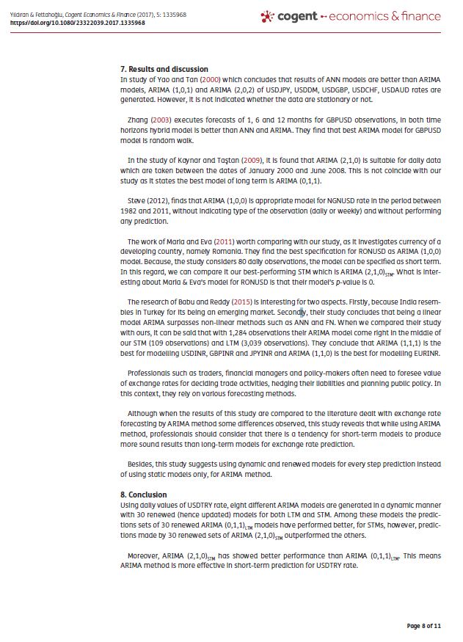

Figure :Results and discussion from the paper titled " Forecasting USDTRY rate by ARIMA method"

# Discussion

Another paper attached talks directly about the results of LSTM compared to other methods.

At the end of these findings it was desired by the group members to unanimously agree to creating a very basic ARIMA model with the closest resemblance of the LSTM model. They settled on a RNN to ensure that incase any non linear (dynamic) model was required incase of removing the limitation of the ARIMA model to find the most attractable forex trade. Hence the code submitted had two models.

(Note: the code submitted generates graphs for analysis)

# References

1. APPLYING SINGULAR SPECTRUM ANALYSIS AND ARIMA-GARCH FOR FORECASTING EUR/USD EXCHANGE RATE

Citation: Abreu, R. J., Souza, R. M., & Oliveira, J. G. (2019). Applying singular spectrum analysis and ARIMA-GARCH for forecasting EUR/USD exchange rate. Revista de Administração Mackenzie, 20(4). doi:10.1590/1678-6971/eRAMF190146

1. Forecasting USDTRY rate by ARIMA method  
   Citation: Yıldıran, Cenk Ufuk; Fettahoæglu, Abdurrahman (2017) : Forecasting USDTRY rate by ARIMA method, Cogent Economics & Finance, ISSN 2332-2039, Taylor & Francis, Abingdon, Vol. 5, Iss. 1, pp. 1-11, <http://dx.doi.org/10.1080/23322039.2017.1335968>
2. An Enhanced Neural-based Bi-Component Hybrid Model for Foreign Exchange Rate Forecasting by M. Khashei, S. Torbat, Z. H. Rahimi, Turkish Journal of Forecasting vol. 01 no. 1 (2017) pp. 16-29
3. Forecasting Foreign Currency Exchange Price using Long Short-Term Memory with K-Nearest Neighbor Method by Rudra Kalyan Nayak, S.Y.H. Pavitra, Ramamani Tripathy, K. Prathyush  
   International Journal of Engineering and Advanced Technology (IJEAT) ISSN: 2249 – 8958, Volume-9 Issue-2, December, 2019, DOI: 10.35940/ijeat.B3551.129219
4. A comparison of Fundamental and Technical Analysis of Linear and Non-Linear models for FOREX prediction by ANGELOS STAMATOPOULOS
5. Foreign Exchange Rates prediction with LSTM by Huy Phung, Tashi Choden, Sahil Pasricha from University of Konstanz, Published: February 2019,